

**Vanpool for a Better Commute**

Join **ADD NAME’s** network at **GetThereOregon. org/ADD NETWORK URL**. Connect with coworkers for carpool, vanpool, and biking trips, and participate in challenges and earn rewards, as available.

**[Employer contact info placeholder]**

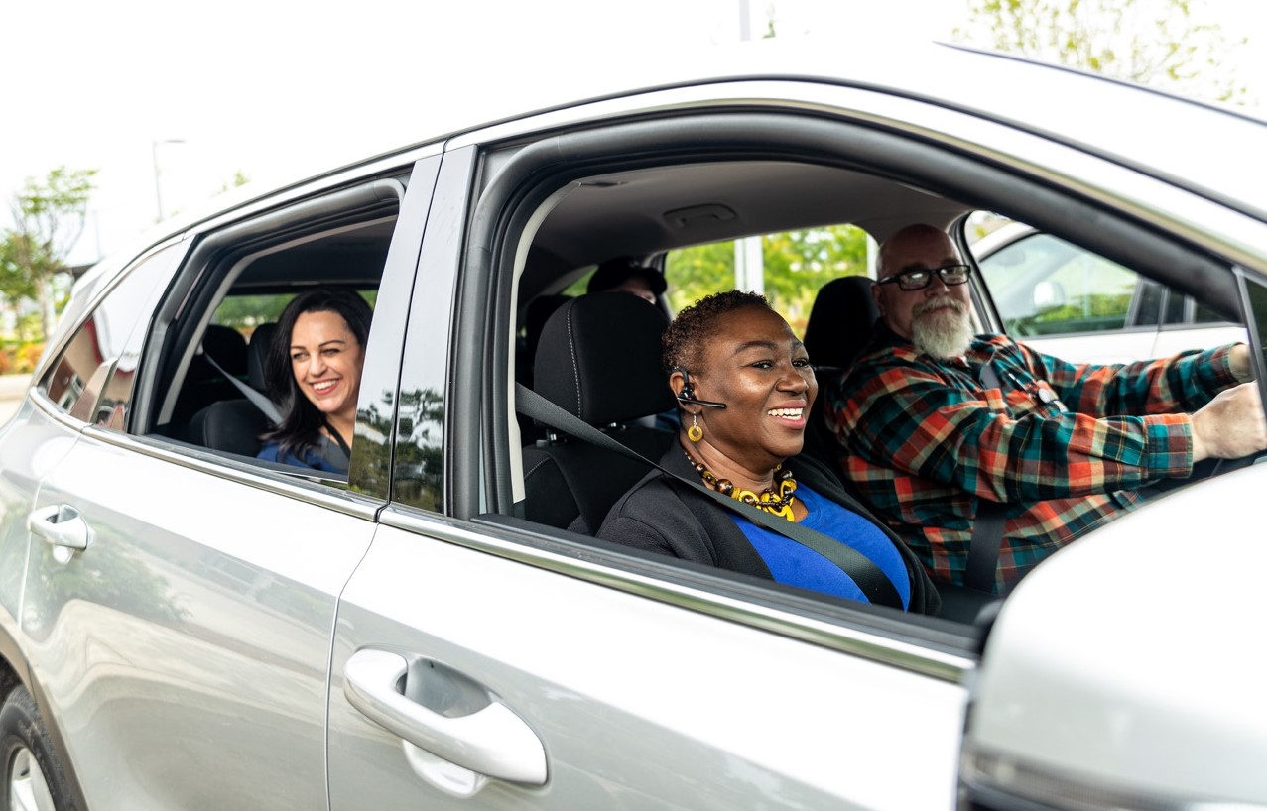

Use Oregon’s free online **Get There Connect** tool to track your stats like

money saved and reduced carbon emissions, join challenges, earn rewards for driving less, and explore more commute options.

**Vanpooling Benefits:**

* **Save money** on gas and vehicle maintenance
* **Enjoy time to relax** from your workday
* **Cut** your carbon footprint
* **Connect** with others

**Find a Vanpool with Get There Connect:**

Visit **GetThereOregon.org**

**Sign up** or **log in** to Get There Connect

Go to your **Dashboard** and enter your commute details in the “My Trips” box

Select “**Save**” and see available vanpools in your area

**1**

**2**

**3**

**4**

**_**

**Long commute? No problem!**

Join or get a vanpool started for a

money-saving and more sustainable way of getting to work. If you have a longer commute (typically 20+ miles), vanpooling is a great option. Vanpools let you share the load of your commute with a large

group (typically 5-15 people).

Can’t find a vanpool to join? Need a vehicle? **Commute with Enterprise** can help you find a vanpool or set a new one up and provides

vehicle rentals, insurance, and 24/7 maintenance.

Learn more at **GetThereOregon.org**

Questions? Contact us at

[**info@GetThereOregon.org**](mailto:info@GetThereOregon.org)

**ADD NETWORK QR CODE HERE**

**EMPLOYER LOGO HERE**