

**Take Transit for a Better Commute**

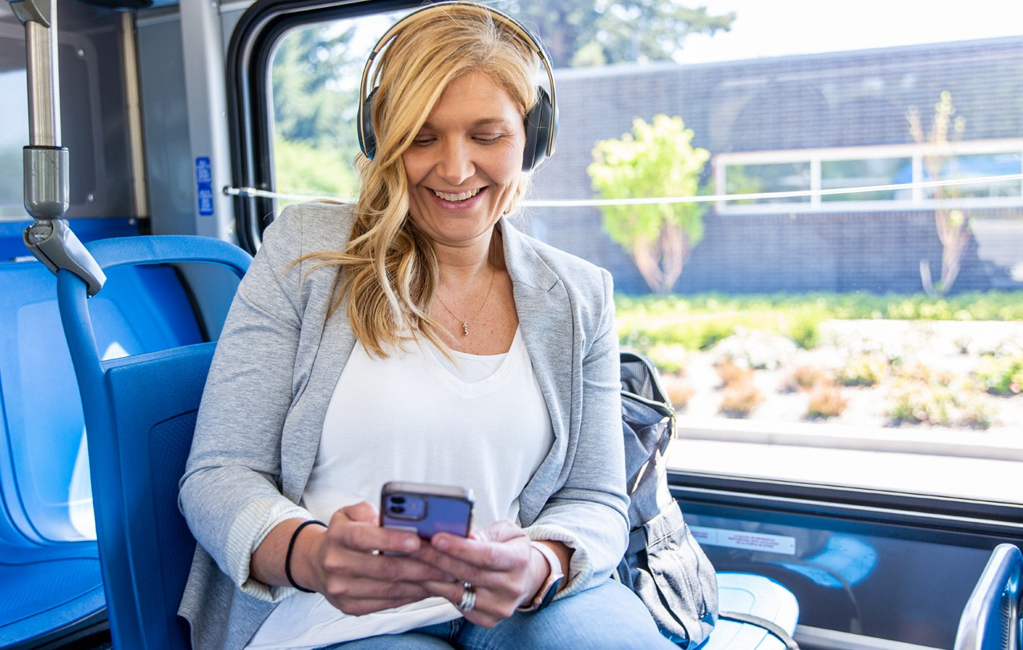

Use **Get There Connect** to track your stats like money saved and reduced carbon

emissions, join challenges, earn rewards for driving less, and explore more commute options.

**Transit Benefits:**

**Save money** on gas, vehicle maintenance, and parking

**Reduce stress** from driving, traffic, and parking

**Enjoy more free time** to relax and have fun

**Reduce** CO2 emissions and air pollution

►

►

►

►

**Riding Transit Tips:**

**Plan ahead:** Use tools like **Get There Connect**, **Google Maps**, or your local transit provider’s website to plan your trip ahead of time.

**Learn about payment options:** With many providers, you can use a mobile app or credit card, while others may require physical tickets or exact fare.

**Look into fare discounts:** If you ride frequently, you might be eligible for fare discounts.

**Arrive early:** Plan on arriving at your transit stop at least five minutes before your departure time.

**Stay up to date:** Visit your local transit provider’s website or app for schedule changes and delays.

**Find a Park & Ride:** If you don’t live near a transit center or bus stop, use **Get There Connect** to find a nearby Park & Ride lot.

►

►

►

►

**_**

**Get on board and let someone else do the driving!**

Enjoy a more stress-free commute and save on commuting costs when you take transit.

►

►

Learn more at **GetThereOregon.org**

Questions? Contact us at

[**info@GetThereOregon.org**](mailto:info@GetThereOregon.org)

Join **ADD NAME’s** network at **GetThereOregon.org/ ADD NETWORK URL**. Connect with coworkers for carpool, vanpool, and biking trips, and participate in challenges and earn rewards, as available.

**[Employer contact info placeholder]**

**ADD NETWORK QR CODE HERE**

**EMPLOYER LOGO HERE**