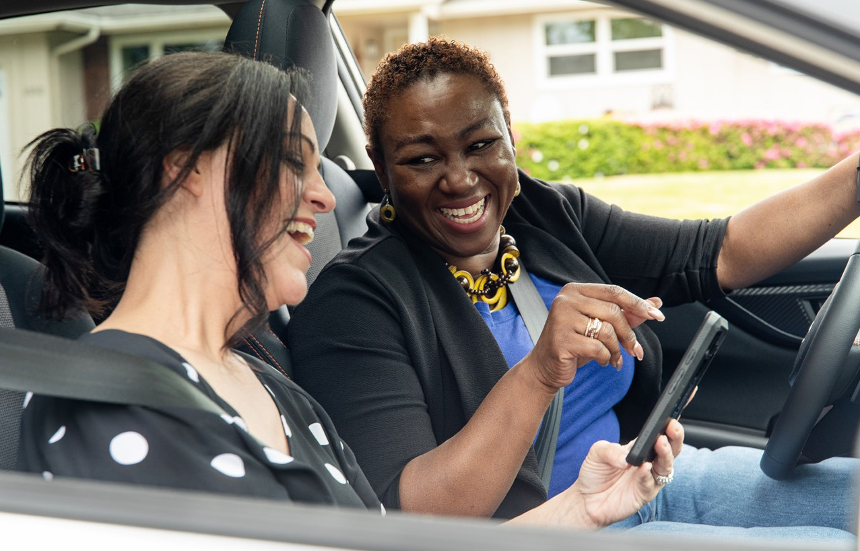

Join **ADD NAME’s** network at **GetThereOregon. org/ADD NETWORK URL**.Connect with coworkers for carpool, vanpool, and biking trips, and participate in challenges and earn rewards, as available.

**[Employer contact info placeholder]**

**With Get There Connect, You Can:**

**Find** and **compare** commute options

**Join** or **start** a carpool or vanpool

**Explore** bike routes and find biking partners

**Find** park and rides and **access** transit

**Track stats** like money saved, calories burned, and reduced CO2

Enter **challenges** and earn **rewards**

►

►

►

►

►

►

**Make Your Commute Better with Get There Connect**

**Discover the Benefits of Commute Options:**

**Save money** on gas, vehicle maintenance and repairs, and even insurance

**Get active** with extra physical activity Enjoy more **free time** to relax and have fun

**Reduce stress** and **burnout** from traffic and longer commutes

**Improve sustainability** by reducing CO2 and environmental impacts

►

►

►

►

►

**Save money**

**Boost your health**

**Getting Started Is Easy:**

Visit **GetThereOregon.org**

**Sign up** or **log in** to Get There Connect

Go to your **Dashboard** to explore your commute options + more!

**1**

**2**

**3**

**Reduce CO**

**2**

**Enjoy the ride**

Discover a better way to commute with **Get There Connect**, Oregon’s free online trip planning, ridematching, and metrics tracking tool.

Learn more at **GetThereOregon.org**

Questions? Contact us at

[**info@GetThereOregon.org**](mailto:info@GetThereOregon.org)

**ADD NETWORK QR CODE HERE**

**EMPLOYER LOGO HERE**