

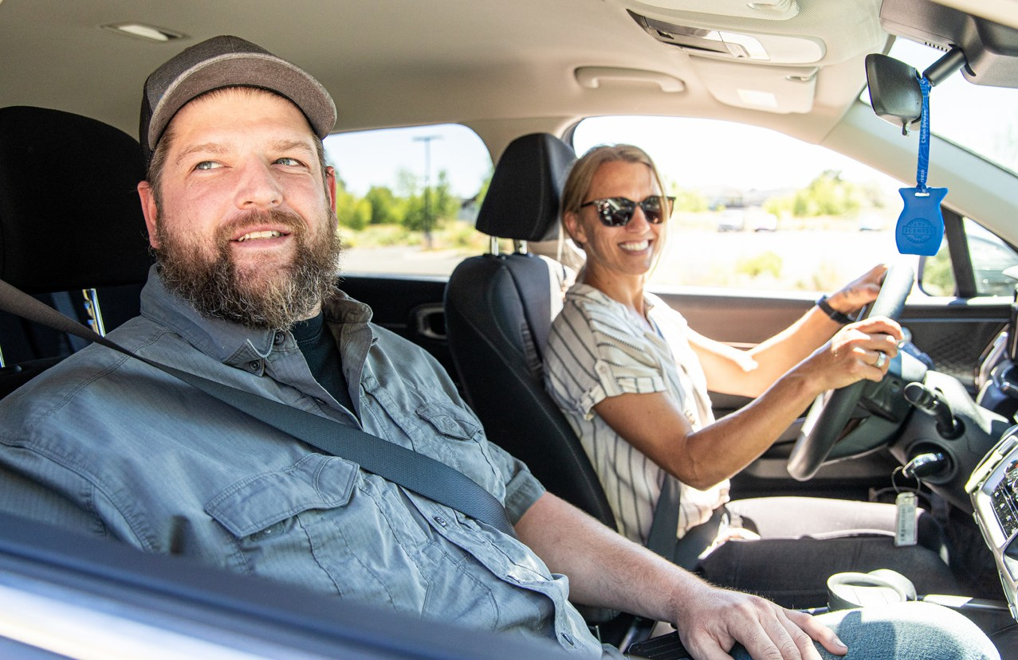

Use Oregon’s free online **Get There Connect** tool to track your stats like money saved and reduced

carbon emissions, join challenges, earn rewards for driving less, and explore more commute options.

Join **ADD NAME’s** network at **GetThereOregon.org/ ADD NETWORK URL**.Connect with coworkers for carpool, vanpool, and biking trips, and participate in challenges and earn rewards, as available.

**[Employer contact info placeholder]**

**Carpool for a Better Commute**

**Carpooling Benefits:**

**Save money** on gas and vehicle maintenance

**Enjoy time to relax** from your workday

**Cut** your carbon footprint

**Connect** with others

►

►

►

►

**Find a Carpool Partner with Get There Connect:**

Visit **GetThereOregon.org**

**Sign up** or **log in** to Get There Connect

Go to your **Dashboard** and enter your commute details in the “My Trips” box

Select “**Save**” and see available carpool options

**1**

**2**

**3**

**4**

**_**

**Sit back, relax, and share the ride!**

Share your commute by carpooling and experience a more affordable, sustainable, and enjoyable way to get to work.

**Tips for Starting Carpools:**

**Figure out logistics**, including who is driving and pick-up points

**Set ground rules** about music, food, drinks, etc.

**Determine how to split up costs** and a payment method

**Make** a carpool schedule

**Enjoy** the ride!

►

►

►

►

►

Learn more at **GetThereOregon.org**

Questions? Contact us at

[**info@GetThereOregon.org**](mailto:info@GetThereOregon.org)

**ADD NETWORK QR CODE HERE**

**EMPLOYER LOGO HERE**