

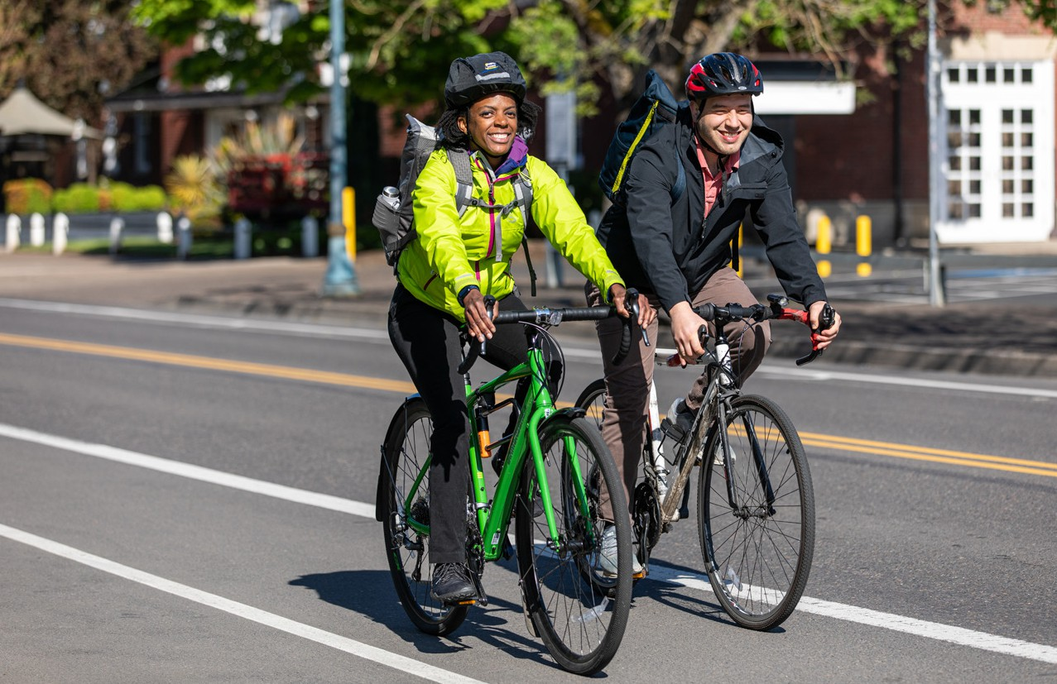

Use Oregon’s free online **Get There Connect** tool to track your stats like

money saved and reduced carbon emissions, join challenges, earn rewards for driving less, and explore more commute options.

**Bike for   
a Better Commute**

**Bike Commuting Benefits:**

Get **active** with increased physical activity

**Reduce stress and boost** your mental health and energy

**Save money** on gas, vehicle maintenance, and parking

**Cut** your carbon footprint

**Explore your community** in a new way

►

►

►

►

►

**Bike Commuting Tips:**

**Dust off your bike** or **find one** that fits your needs

**Plan and practice** your route using tools like

**Get There Connect** and **Google Maps Read up** on bicycle safety

Be sure your bike is **tuned up before heading out**

Give yourself some **extra time**

►

►

**_**

**Enjoy an active, more affordable commute!**

Join the movement and start commuting to work by bike! Pedal past traffic, get an active start to your day, and save money on commuting costs.

Learn more at

**GetThereOregon.org**

Questions? Contact us at

[**info@GetThereOregon.org**](mailto:info@GetThereOregon.org)

►

►

►

Join **ADD NAME’s** network at **GetThereOregon. org/ADD NETWORK URL**.Connect with coworkers for carpool, vanpool, and biking trips, and participate in challenges and earn rewards, as available.

**[Employer contact info placeholder]**

**ADD NETWORK QR CODE HERE**

**EMPLOYER LOGO HERE**